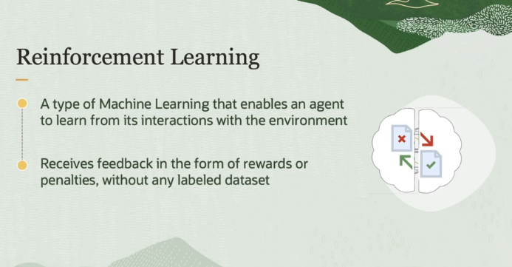

In this lesson, we will learn about reinforcement learning. Reinforcement learning is like teaching a dog new tricks. You reward it when it does something right. And over time, it learns to perform these actions to get more rewards.

More formally, reinforcement learning is a type of machine learning that enables an agent to learn from its interaction with the environment, while receiving  feedback in the form of rewards or penalties without any label data. Let us look at some examples.

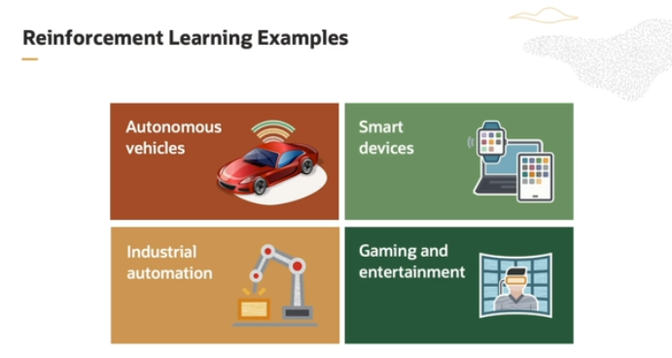

**1. Autonomous Vehicles (Self-driving cars and drones):**

* **How it works:** Self-driving cars and autonomous drones constantly gather information from their environment using sensors (like cameras, radars, and GPS). Reinforcement learning helps these vehicles make decisions in real-time, such as avoiding obstacles, deciding the best route, and following traffic rules.
* **Why RL is useful:** It allows the car to improve its driving over time, learning from both successful experiences (like safely crossing an intersection) and mistakes (like swerving too close to the curb).

**2. Smart Home Devices (Virtual Assistants):**

* **How it works:** Virtual assistants like Alexa, Google Assistant, or Siri use reinforcement learning to improve their natural language processing abilities. They adapt to your voice, learn your preferences, and get better at predicting what you need over time.
* **Why RL is useful:** Reinforcement learning allows these assistants to give you more personalized responses. For example, if you always play a particular playlist in the morning, the assistant will learn to suggest it at the right time.

**3. Industrial Automation (Robots and Control Systems):**

* **How it works:** In factories or production lines, robots and control systems use reinforcement learning to optimize their performance. This could be improving the speed of production or reducing the number of errors in assembling products.
* **Why RL is useful:** The robots can learn from their past mistakes and make fewer errors over time, improving efficiency and reducing downtime in manufacturing.

**4. Gaming and Entertainment (AI opponents and Virtual Reality):**

* **How it works:** In video games, the computer-controlled characters (AI) use reinforcement learning to adapt to how you play. As you improve at the game, the AI opponents learn and become more challenging to beat.
* **Why RL is useful:** This creates a dynamic and engaging experience for players, as the AI becomes smarter and more difficult to defeat, making the game more fun and unpredictable.

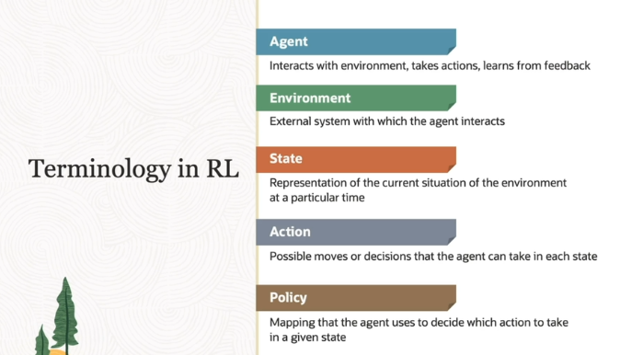

Let's break this down step by step using the self-driving car example, to help you understand the key terms used in reinforcement learning:

**1. Agent:**

* **What is it?** The **agent** is the learner or decision-maker.
* **In our example:** The self-driving car is the agent. It's the entity that makes decisions (like steering) while driving on the road.
* **Formal definition:** An agent interacts with its environment, takes actions, and learns from the feedback it receives.

**2. Environment:**

* **What is it?** The **environment** is the world in which the agent operates. It provides the setting or context in which the agent takes actions.
* **In our example:** The **road** and its surroundings (such as other cars, signs, and obstacles) are part of the environment. The car (agent) interacts with this environment.
* **Formal definition:** The environment is the external system or space that the agent interacts with and where it receives feedback based on its actions.

**3. State:**

* **What is it?** The **state** is the current situation or view of the environment at a specific moment in time.
* **In our example:** The car’s camera captures what is in front of it at a given moment. This view is the state at that moment.
* **Formal definition:** The state is a snapshot of the environment that contains enough information for the agent to decide what action to take next.

**4. Actions:**

* **What are they?** **Actions** are the possible moves or decisions the agent can make based on the current state.
* **In our example:** The car (agent) can choose to:
  + Turn **left**
  + Turn **right**
  + Drive **straight**
* **Formal definition:** Actions are the decisions available to the agent in a given state. These actions impact the environment and influence future states (e.g., if the car turns left, the environment changes, and a new state appears).

**5. Policy:**

* **What is it?** A **policy** is a strategy or set of rules that tells the agent what action to take in each state.
* **In our example:** The car develops a policy through experience. For example, if it sees a sharp turn on the road (the state), the policy might be to steer to the left. After driving many times, the car learns the best action (policy) for each situation it encounters.
* **Formal definition:** The policy is the agent’s strategy for making decisions. It maps states to actions, guiding the agent on which action to take in any given state.

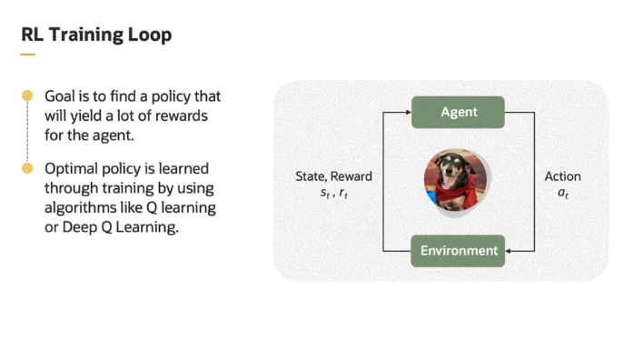

This explanation uses the analogy of training a dog to understand how reinforcement learning (RL) works, particularly the process of learning through rewards and punishments. Let's break it down step by step.

**1. Agent and Environment:**

* **Agent:** In the dog example, the dog is the agent. It is the one learning and making decisions.
  + **In reinforcement learning:** The **agent** could be a robot, a self-driving car, or any system we want to train to make decisions.
* **Environment:** The environment is where the dog learns and interacts, such as the training field.
  + **In RL:** The **environment** is the external setting where the agent performs actions and receives feedback. This could be a virtual simulation, a video game, or the physical world.

**2. Reward System:**

* **Reward/Punishment:** When the dog performs a trick correctly, you give it a treat or positive reinforcement (reward). If it fails, you may give it a warning or some form of negative feedback (punishment).
  + **In RL:** Similarly, the agent is rewarded for good decisions and penalized for bad ones. The goal is to maximize rewards over time.
  + **Example in RL:** If a robot is trying to navigate a maze, reaching the exit could be the reward, while hitting walls might be considered a penalty or negative reward.

**3. Policy:**

* **What is it?** In this context, the **policy** is the "brain" of the agent. It is a set of rules or a strategy that guides the agent in making decisions in different situations.
  + **In dog training:** The policy is what the dog learns: "When I hear the command 'sit,' I should sit to get a treat."
  + **In RL:** The policy is what the machine learns: "In this situation, I should perform this action to get the highest reward."
* **Optimal Policy:** The **optimal policy** is the best set of rules that helps the agent get the most rewards.
  + **In dog training:** The dog eventually learns the best way to respond to different commands to get the most treats (rewards).
  + **In RL:** The agent keeps learning and improving until it discovers the **optimal policy** that maximizes its rewards.

**4. Learning Process:**

* **In RL:** The agent doesn't know the optimal policy initially. It learns by interacting with the environment, trying different actions, and receiving feedback in the form of rewards or penalties.
  + **Example:** The agent might initially take random actions, but over time, it starts to understand which actions lead to better outcomes. This process is known as **exploration and exploitation.**
* **Algorithms like Q-Learning or Deep Q-Learning:** These are techniques that help the agent learn the best policy. They use mathematical methods to figure out how the agent should act to get the most rewards.
  + **Q-Learning:** Helps the agent learn the value of each action in different situations by calculating rewards over time.
  + **Deep Q-Learning:** A more advanced method using neural networks to handle more complex environments.

**Summary of the Process:**

1. **Agent (dog)** interacts with its **environment (training field)**.
2. The agent takes actions and receives **rewards or penalties** based on whether it performed well or poorly.
3. The agent learns a **policy** (the strategy to make decisions) over time through trial and error.
4. The **optimal policy** is the best strategy the agent can follow to maximize rewards.
5. Algorithms like **Q-Learning** or **Deep Q-Learning** are used to help the agent learn and refine its policy.

In both dog training and reinforcement learning, the agent improves over time by learning which actions lead to the best outcomes based on feedback. Eventually, the agent (or dog) becomes proficient in making the right decisions.

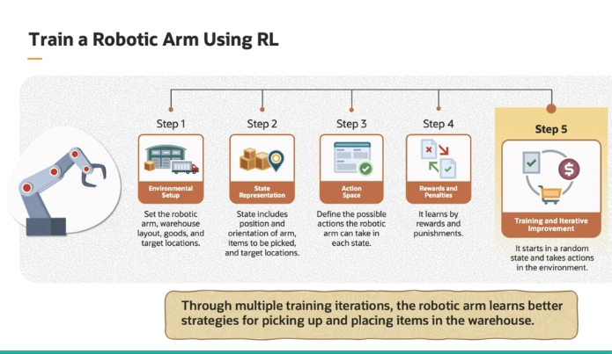

Let's break down the example of using reinforcement learning (RL) to train a robotic arm for warehouse optimization, based on the explanation in the transcript and the image provided.

**1. Environment Setup:**

* **What is the environment?**
  + In this case, the **environment** consists of the robotic arm, the warehouse layout, the goods (items to be picked up), and the target locations (where each item needs to be placed).
  + Think of this as the workspace where the robot operates. The robot interacts with this environment by moving items from one place to another.

**2. State Representation:**

* **What is a state?**
  + The **state** represents the current condition of the robotic arm and its surroundings at a specific time.
  + For the robotic arm, the state could include:
    - The **position and orientation** of the arm.
    - The **location of the items** to be picked up.
    - The **target locations** where the items need to be placed.
  + The robotic arm uses this information to decide its next action.

**3. Action Space:**

* **What is the action space?**
  + The **action space** is the set of all possible actions the robotic arm can take at any given state.
  + For example, actions could include:
    - Moving the arm left or right.
    - Lifting or lowering the arm.
    - Gripping or releasing an item.
  + The robot decides which action to take based on the current state, and each action affects the environment (e.g., moving the item or damaging it).

**4. Rewards and Penalties:**

* **What is the reward system?**
  + The robotic arm is given **rewards** for good actions and **penalties** for bad actions.
  + Examples of rewards:
    - Successfully placing an item in the correct location.
    - Picking up an item without dropping it.
  + Examples of penalties:
    - Dropping an item.
    - Damaging goods.
    - Failing to place items correctly.
  + The goal is to encourage the robot to perform actions that maximize rewards while avoiding penalties.

**5. Training the Robotic Arm:**

* **How does the learning process work?**
  + Initially, the robotic arm doesn’t know which actions will lead to rewards or penalties, so it **explores** by randomly trying different actions.
  + It observes which actions result in rewards (positive outcomes) and which lead to penalties (negative outcomes).
  + Over time, the robotic arm **learns** to prioritize actions that maximize rewards. This process is called **exploitation**—where the arm sticks to actions that have led to positive outcomes in the past.
  + Through multiple training iterations (repeated trials), the robotic arm becomes more efficient at picking up and placing items.

**6. Optimization Over Time:**

* As the robotic arm continues to train, it develops strategies that help it **optimize** the process of moving items. It starts to take actions that lead to more efficient and accurate placements while minimizing mistakes like dropping or damaging goods.
* This happens because the arm learns a **policy**—a strategy that helps it decide the best action to take in any given situation.